##### **Instagram User Analytics**

**Description:**

**The Instagram User Analytics project is an insightful real-time project where we have been allotted some questions related to marketing campaigns and Investors Metrics.**

**Approach:**

**I have adopted an approach, where I took this project as no less than a real-time project and analyzed all the available information.**

**Tech Stack Used:**

**MySQL Workbench and DB-fiddle.**

**Marketing Report Analysis**

1. **Marketing:**
2. **Rewarding Most Loyal Users: we have to find out the users who have been using Instagram from the very start.**

**Task: Find the 5 oldest users of Instagram from the database provided**

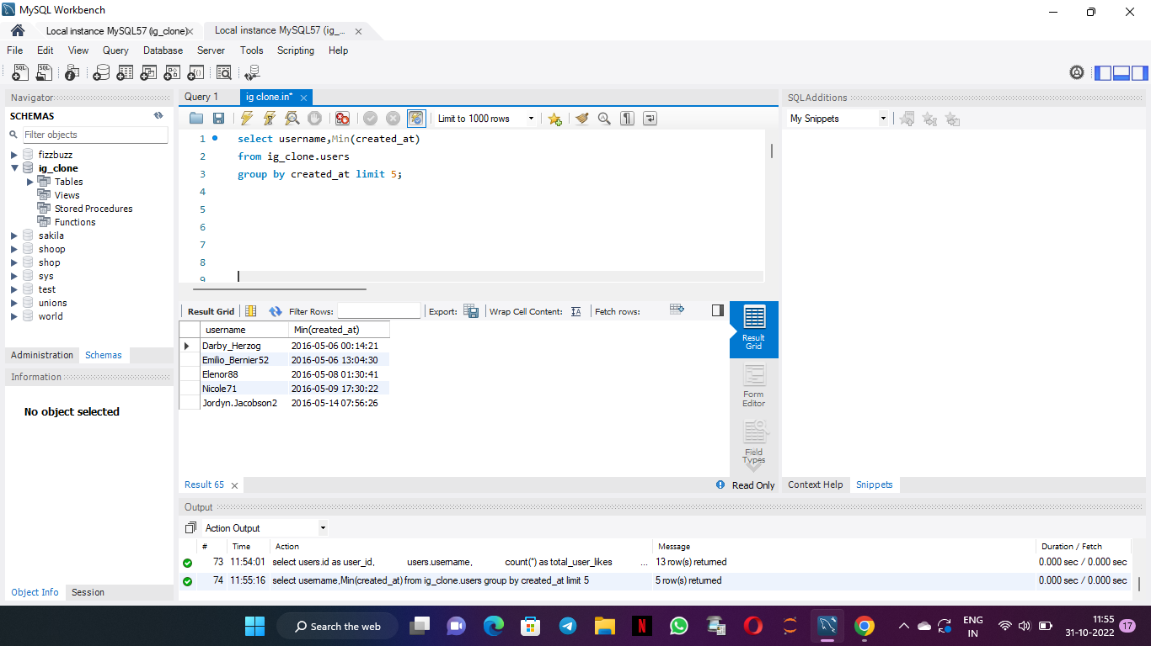

Query:

select username,Min(created_at)

from users

group by created_at limit 5;

1. **Remind Inactive Users to Start Posting**

**Task: Find the users who have never posted a single photo on Instagram**

Query:

select username

from users

where id Not in (select user_id from photos)

order by username;

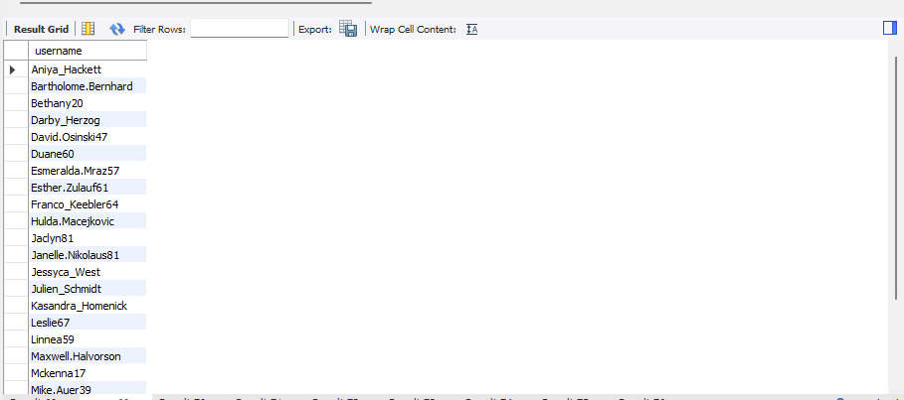

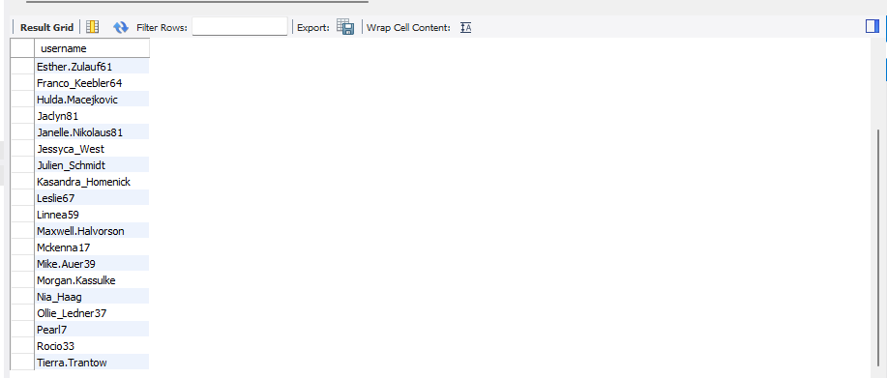

1. **Declaring Contest Winner**

**Task: Identify the winner of the contest and provide their details to the team.**

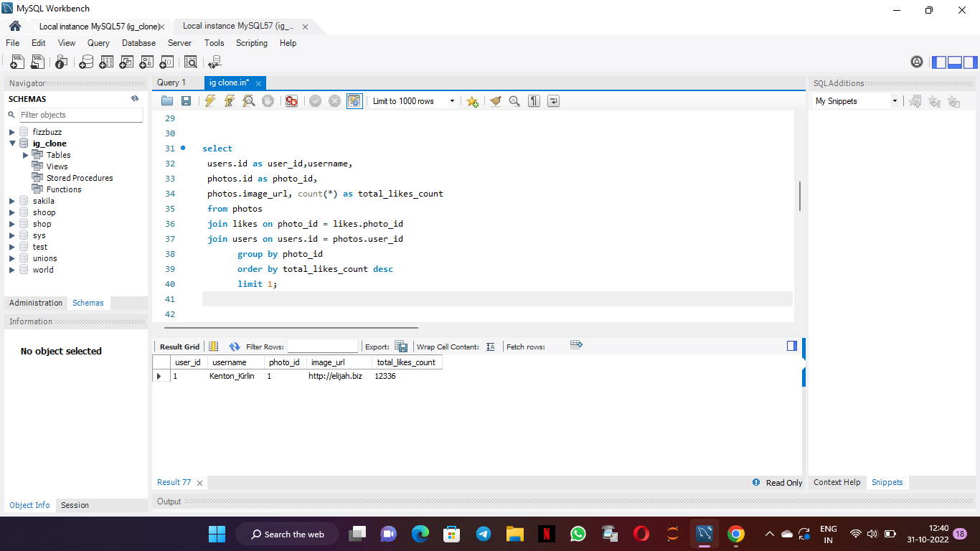

Query:

Select

users.id as user_id,username,

photos.id as photo_id,

photos.image_url, count(*) as total_likes_count

from photos

Join likes on photo_id = likes.photo_id

join users on users.id = photos.user_id

group by photo_id

order by total_likes_count desc limit 1;

1. **Hashtag Researching**

**Task: Identify and suggest the top 5 most commonly used hashtags on the platform**

Query: select

tag_name, tags.id,

count(*) as total_tags

from tags

join photo_tags on tags.id = photo_tags.tag_id

group by tags.id

order by total_tags desc

limit 5;

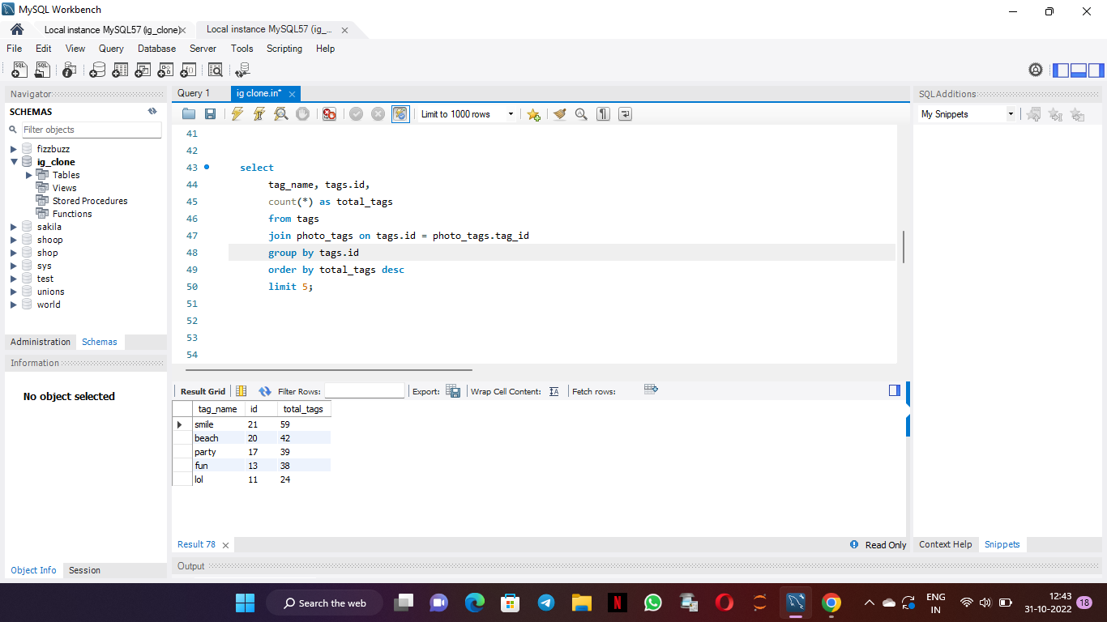

1. **Launch AD Campaign**

**Task: What day of the week do most users register on? Provide insights on when to schedule an ad campaign.**

Query:

select *,dayname(created_at) as day, count(*) as total_count

from users

group by day

order by total_count desc;

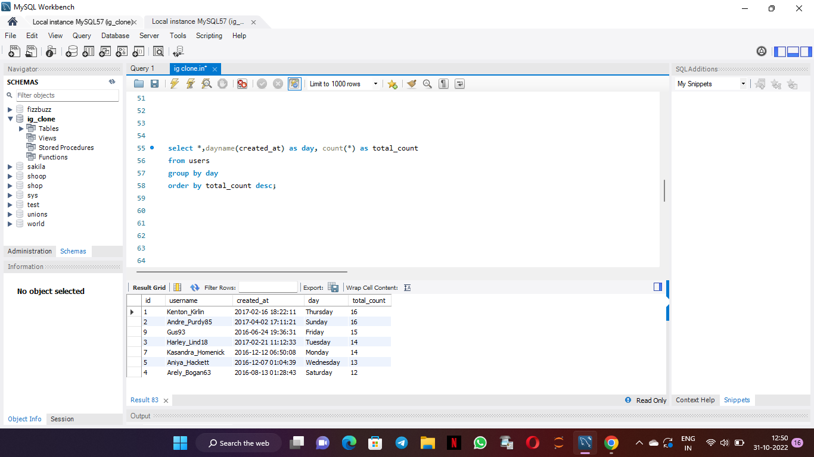

**B) Investors Metrics**

1. **User Engagement**

**Task: Provide how many times does average user posts on Instagram. Also, provide the total number of photos on Instagram/total number of users.**

**Query:**

WITH CTE as

(select

u.id as userid,

count(p.id) as photoid

from ig_clone.users u

left join

ig_clone.photos p

on u.id = p.user_id

group by u.id)

select sum(photoid) as total_photos,

count(userid) as total_users,

sum(photoid)/count(userid) as post_per_user from CTE

where photoid > 0;

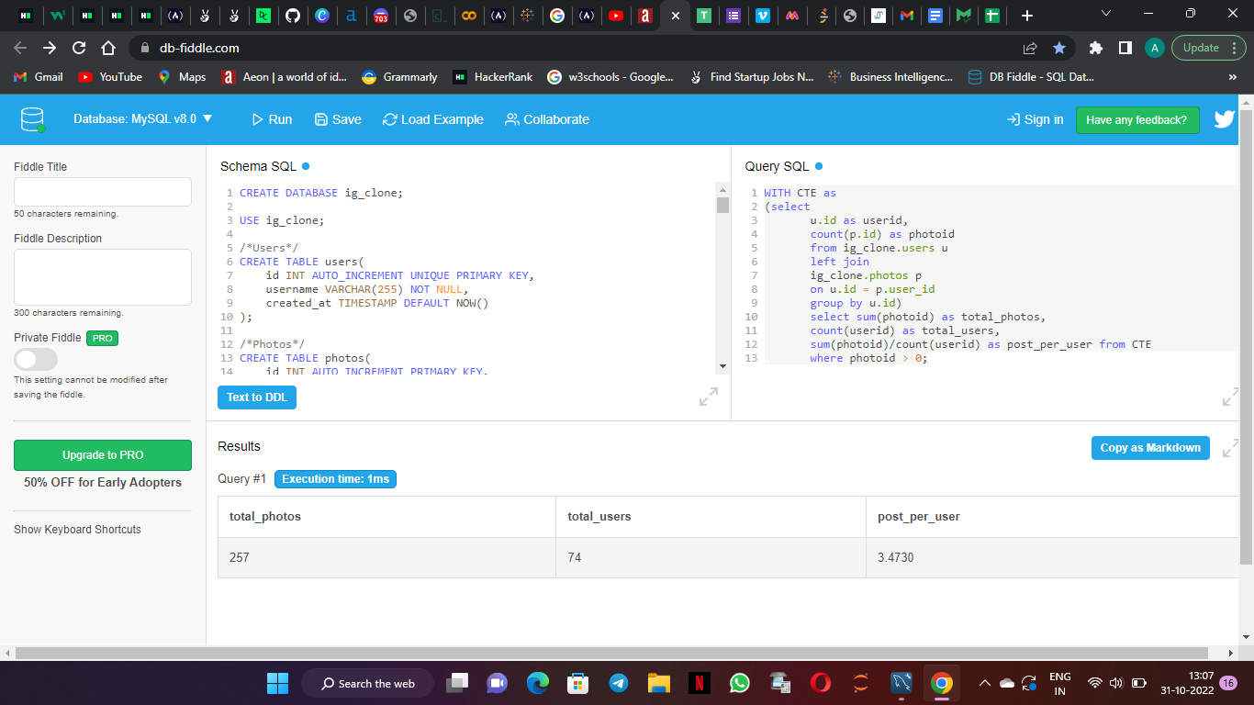

1. **Bots and Fake Accounts**

**Task:Provide data on users (bots) who have liked every single photo on the site (since any normal user would not be able to do this).**

**Query:**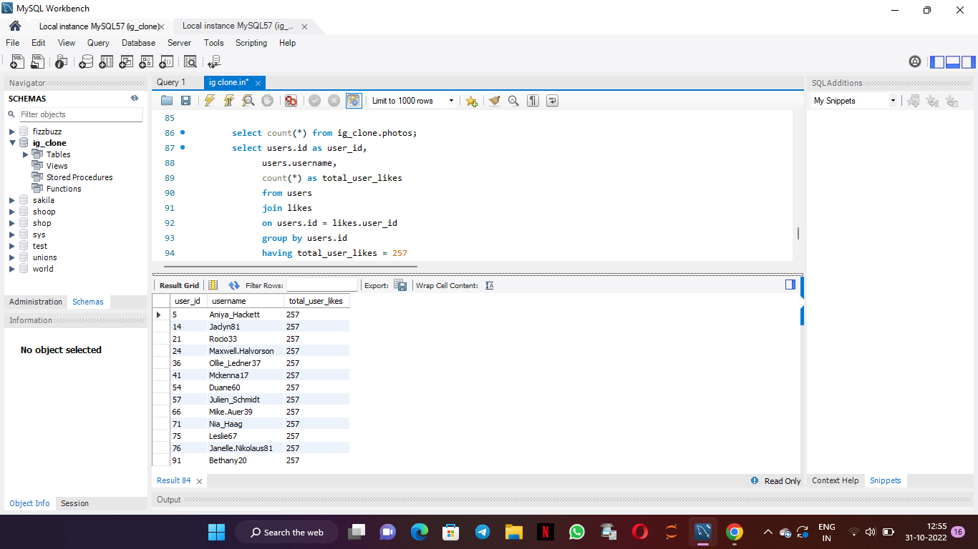

select count(*) from ig_clone.photos;

select users.id as user_id,

users.username,

count(*) as total_user_likes

from users

join likes

on users.id = likes.user_id

group by users.id

having total_user_likes = 257

;